Assignment 6

Name Muhammad Ali

Sid 9363

Cid 102326

Design A Bus Network Which Consist Of Three Router Attach Two Pc With Router 1 Switch And Three Pc With Router 3 Switch Attach A Webserver With Router 1 Switch Configure Extended Acl On This Network So That All The Authorize User Can Acess Webserver While Unautherize Should Be Restricted Each Student Will Use Acl Id 191 As Per Assigned In Lab Session Also Configure Rip1 On This Network

Network Diagram

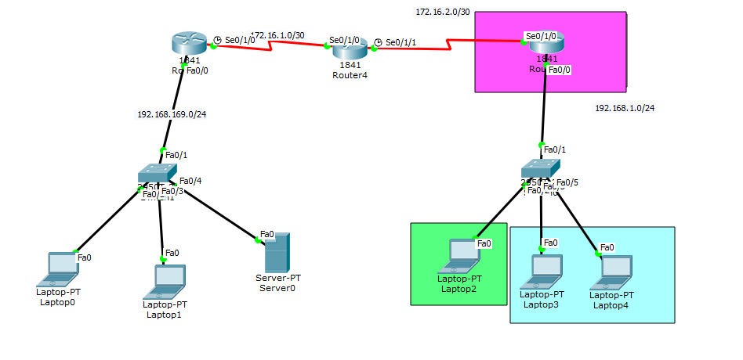

R3 Show Running

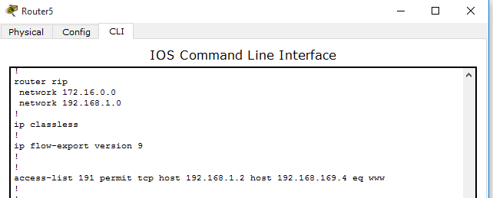

ACL Code

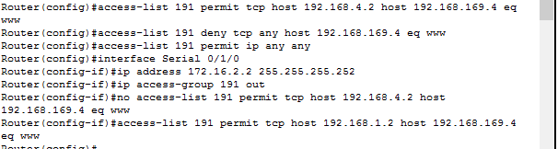

Authorize PC Webpage

